**Sprint-2**

|  |  |
| --- | --- |
| Date | 7 November 2022 |
| Team ID | PNT2022TMID08358 |
| Project Name | Industry-Specific Intelligent Fire Management System |

**MONITORING SENSOR VALUES**

# Display the temperature values in the dashboard:

Submitted by: Rathidevi,Nandhini,Parwin,Preethi,Sathya

Student Roll number:810419104094,810419104067,810419104078,810419104091,810419104100

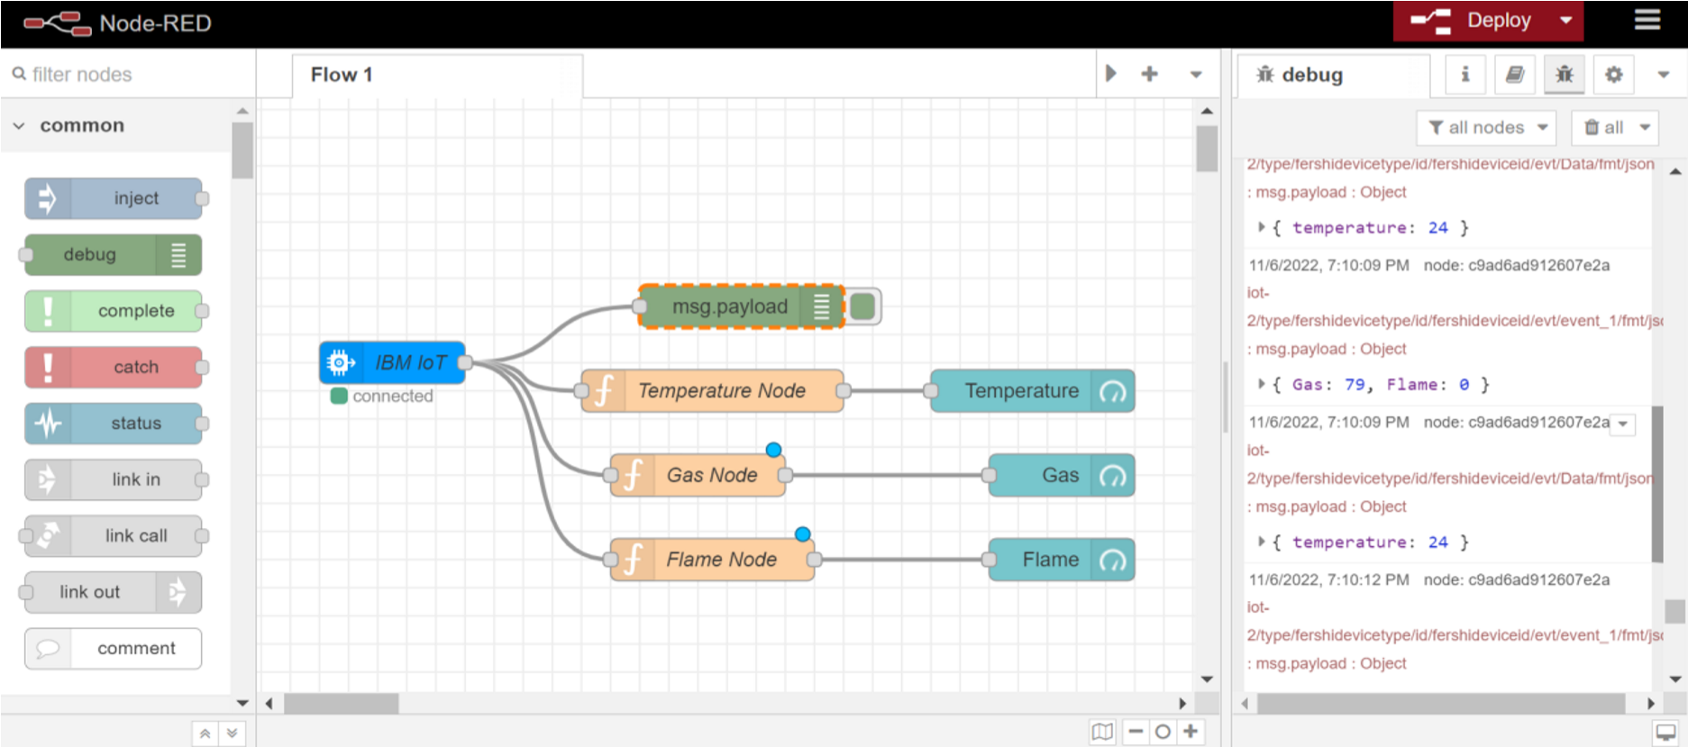

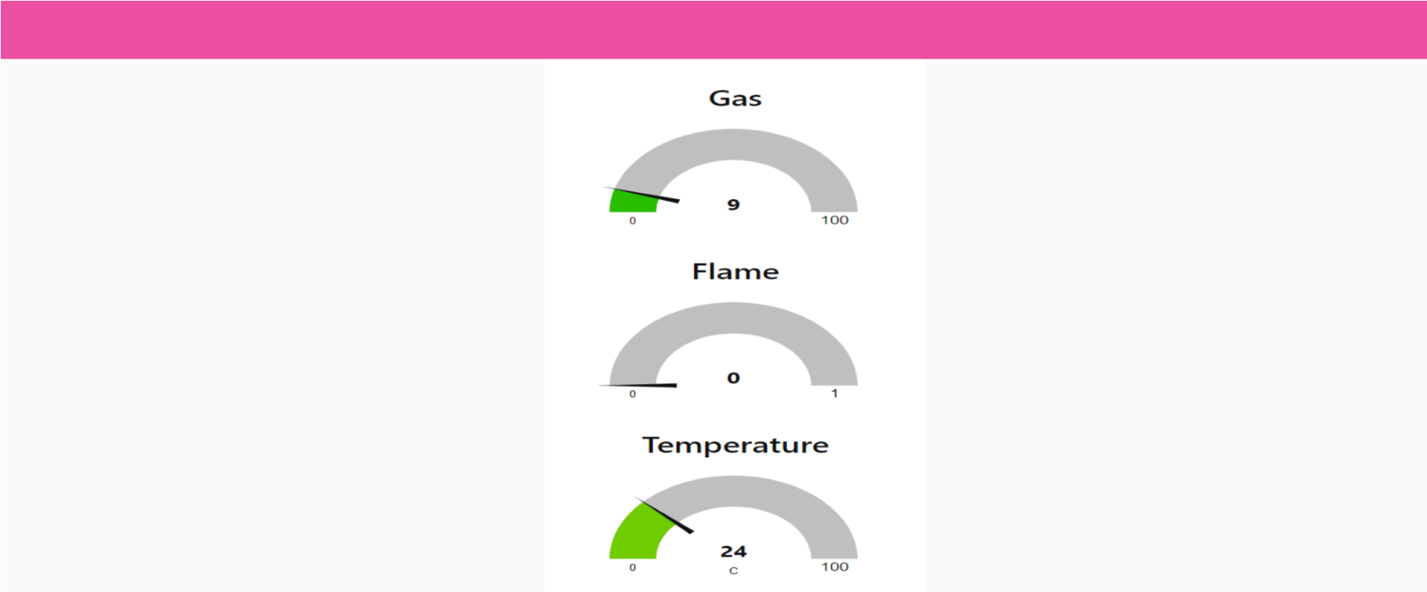

# Displaying flame sensor values:

Submitted by:Godsy D,Aswini A

Student Roll

no:962819106016,962819106008

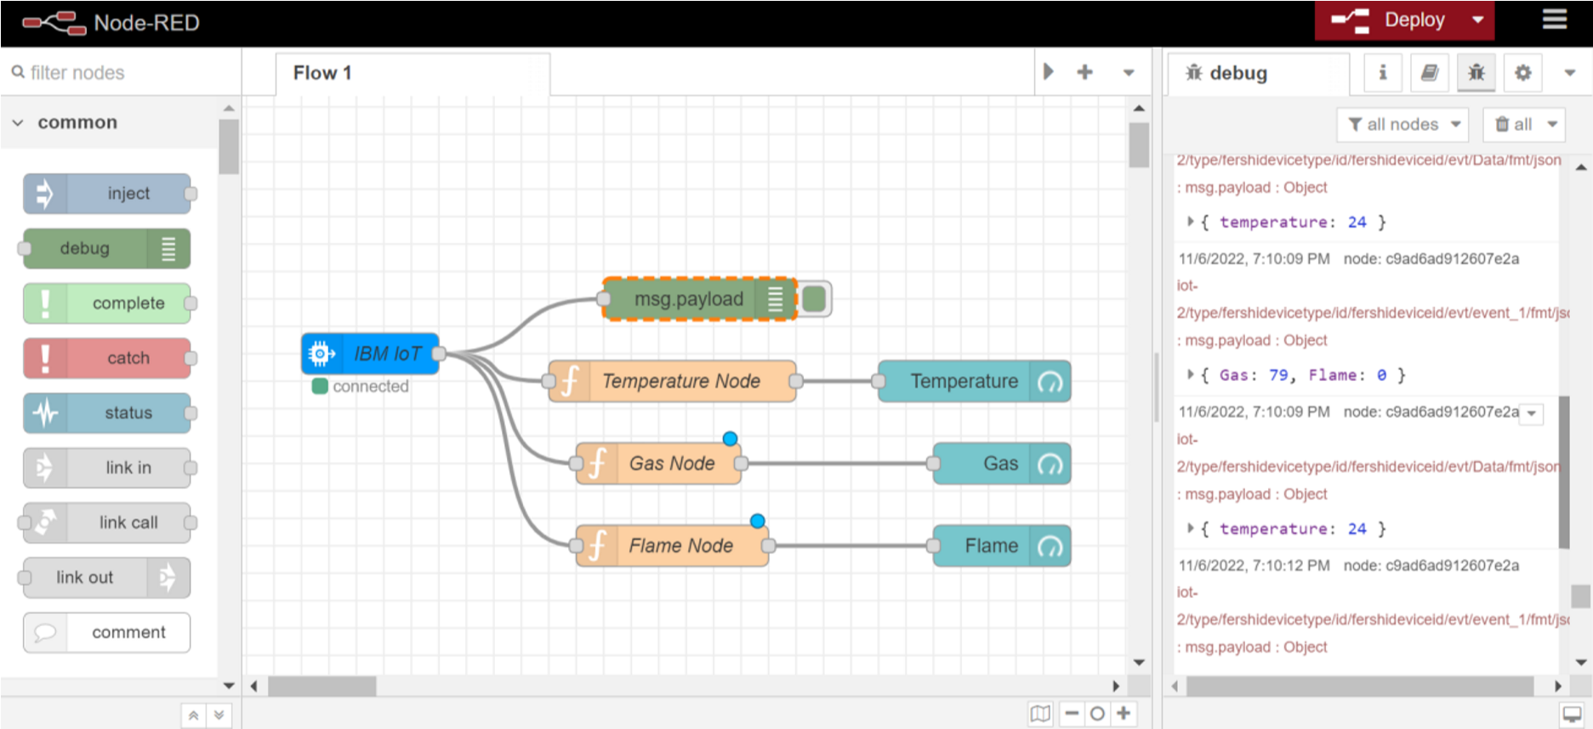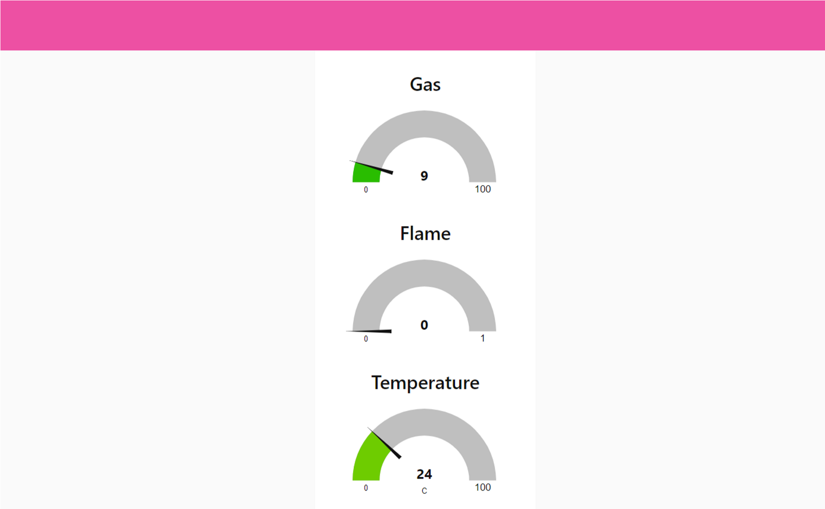

# Displaying gas sensor values:

Submitted by:Fershia G Geona,Reshma Xavier

Student Roll no:962819106014,962819106033

